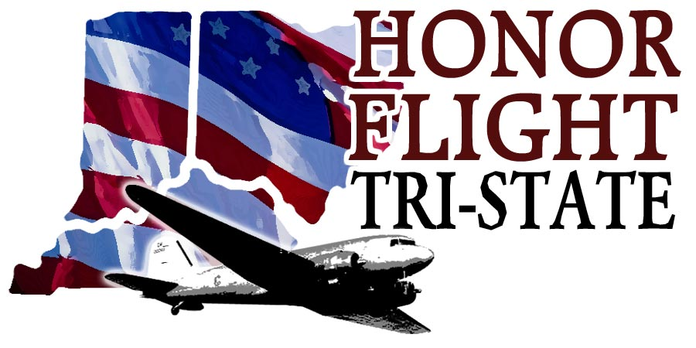

Headquarters
8627 Calumet Way
Cincinnati, OH 45249
513-489-2022
www.honorflighttristate.org

UPDATED: February 1, 2021

NEWS RELEASE FROM HONOR FLIGHT TRI-STATE
for immediate release

COVID-19 has impacted all of our lives this year, especially the veterans. Honor Flight Tri-State leadership has been in communication with our charter partner, American Airlines ,and medical professionals, regarding contingency plans.

Our mission is in our name - we honor the service and sacrifice of our nation's veterans. With this mission in mind, the health and safety of our veterans is our top priority. Given the current spread of COVID-19 and vaccine schedule for all age groups, the next couple of months will be critical to the resumption of our flights. We have decided to postpone the April 20th and May 18th Honor Flights from CVG.

American Airlines shares our priority in keeping our Veterans safe and healthy and has generously agreed to postpone our charter flights to a later date without any additional charge. As an organization that runs solely on donations, we are fortunate to keep our veterans safe without costly fees.

We understand this postponement will create schedule and travel challenges for veterans and guardians already scheduled to fly in April and May. We apologize for this inconvenience and disappointment and we appreciate your patience as we shift gears and start to plan for future flight dates. We will stay in contact and share updates as we know more.

Our veterans put their lives on the line to defend us - and now it our turn to protect them and their health.

Thank you,

Cheryl Popp, Chairman of the Board
Jennifer Selm, Board of Directors
Liz Keating, Board of Directors
Todd Cain, Board of Directors
Ty Hogan, Board of Directors

